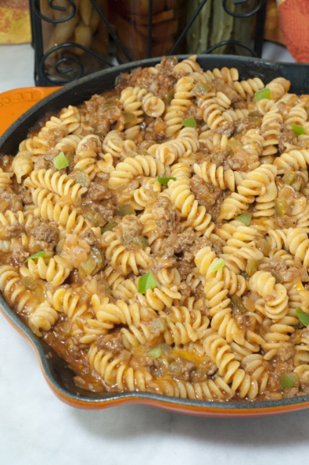
Sloppy Joe Mac and Cheese
Prep time 10 min Cook time 20 min
6 Servings
Ingredients
Sauce
1½ cup tomato sauce
4 tbsp brown sugar
2 tbsp tomato paste
4 tsp Worcestershire sauce
1 tsp salt
½ tsp ground black pepper
Everything Else
1 lb rotini or other similar pasta
2 tbsp olive oil
1½ cups diced onion
1 green bell pepper, diced (about 1 cup)
5 cloves garlic, minced
1 tsp Paprika
1 tsp apple cider vinegar
½ tsp ground mustard
1 lb ground beef
2 cups shredded cheddar cheese
Directions
- In a mixing bowl, combine all the ingredients for the sauce and set aside.
- Cook the pasta in a large pot of salted, boiling water according the directions on the package and then drain.
- Heat the olive oil in a large skillet over medium-high heat. Add the diced onion, green pepper and garlic. Sauté for about 5 minutes or until fragrant and veggies are soft.
- Add the ground beef, apple cider vinegar, ground mustard, and paprika to the same skillet and break up the beef as it cooks all the way through, about 6 to 8 minutes.
- Add the sauce, drained pasta and cheese to the skillet.
- Turn the heat down to medium-low and stir the mixture until the cheese has thoroughly melted and the ingredients are evenly coated and distributed.

